**How to check if server PC infects virus and to remove it?**

If your server PC has one of below problems, right click on “My Computer” > “Manage” >”Service and Application” to check if there is a fake program **”Microsoft Security Center(2.0) Service”** in your services when you can login and control the PC.

1. PC hangs.
2. PC auto reboot.
3. Blue screen.

If you find this program, it means your server PC infects virus.

*Below link describes more about Microsoft Security Center(2.0) Service for reference.

<https://www.bleepingcomputer.com/startups/mssecsvc.exe-29236.html>

Please follow below steps to scan and remove the virus:

**Step1.** To stop “Microsoft Security Center (2.0) Service”.

Right click on “My Computer” > “Manage” > ”Service and Application” > Double click on “Microsoft Security Center(2.0) Service” > To stop it.

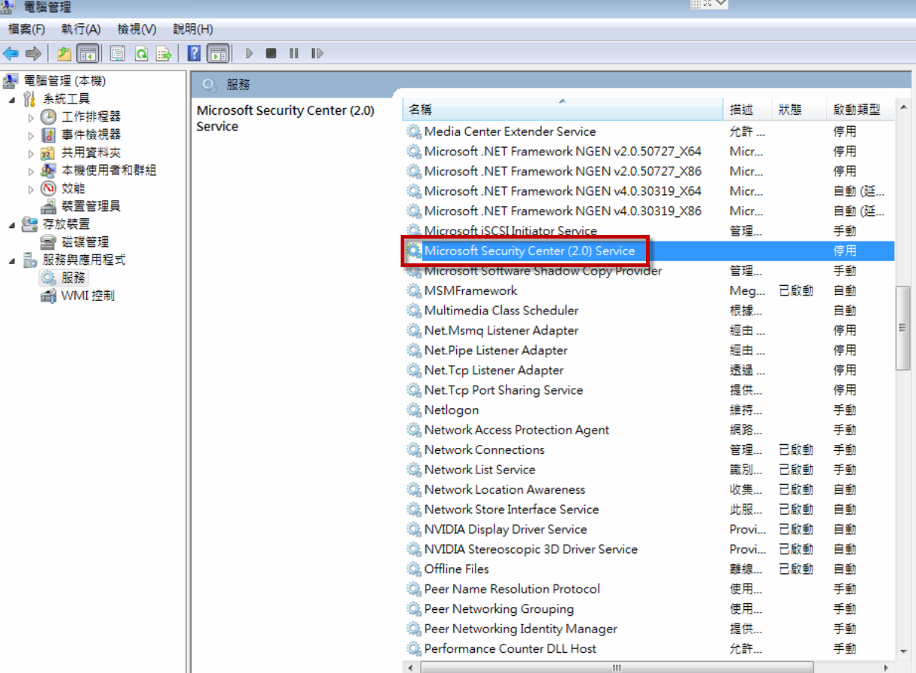

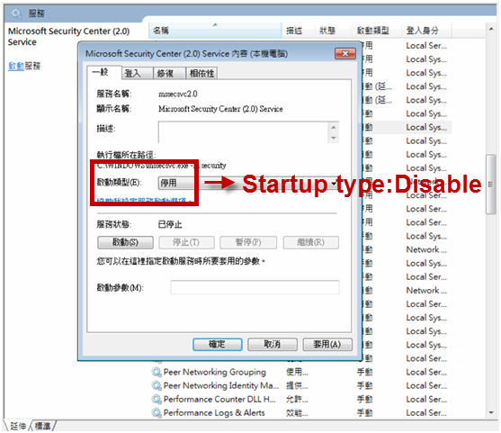

**Step2.** Download Kaspersky Virus Removal Tool：<https://www.kaspersky.com/downloads/thank-you/free-virus-removal-tool>

**Step3.** Pull out the PC ethernet cable to prevent the virus attacking again via Internet Neighborhood.

**Step4.** Run Kaspersky Virus Removal Tool > Click **"Change parameters"**

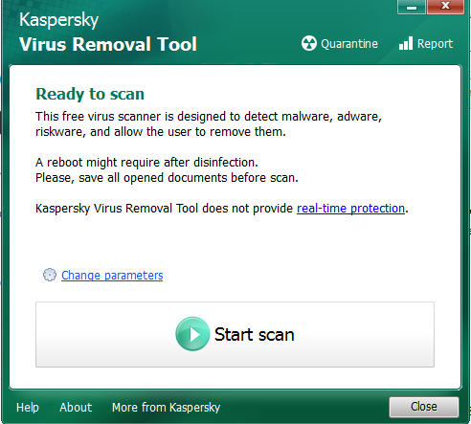 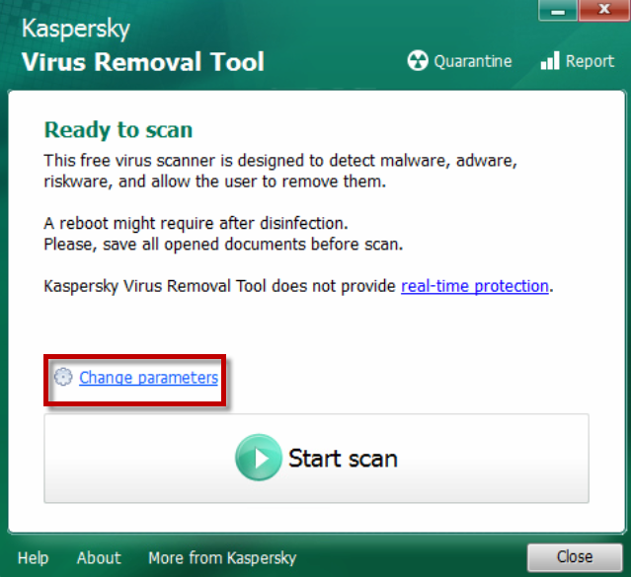

**Step5.** Select **"Startup objects、Boot sectors、System drive"** > **"OK"**

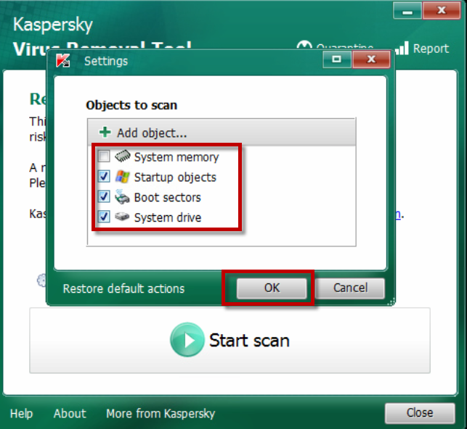

**Step6.** Click **"Start scan".**

Note：The scan process needs 40-50 minute. (It base on the efficacy of PC.) Please do not close the window.

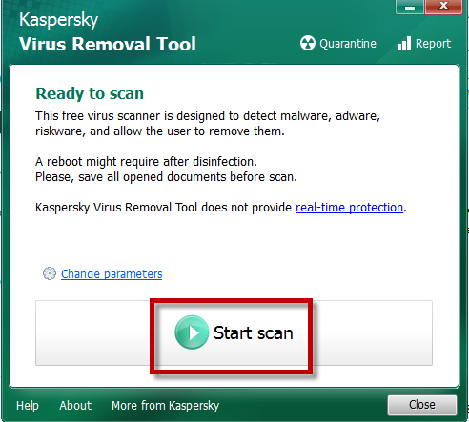

Step 7. After finished, it will show scanresult on screen：

* Normal：No virus found.

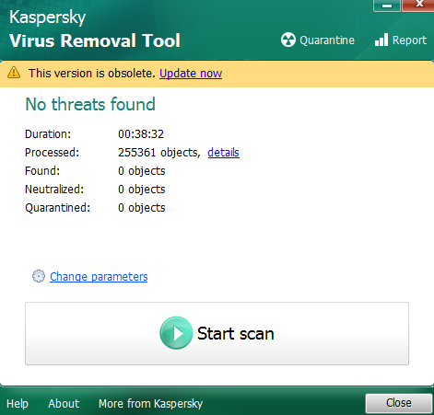

* Abnormal：The Kaspersky Virus Removal Tool will show the virus and workaround. We suggest customer to remove those programs and then restart PC/NB.

|  |  |
| --- | --- |
|  |  |